DLPAR Screen
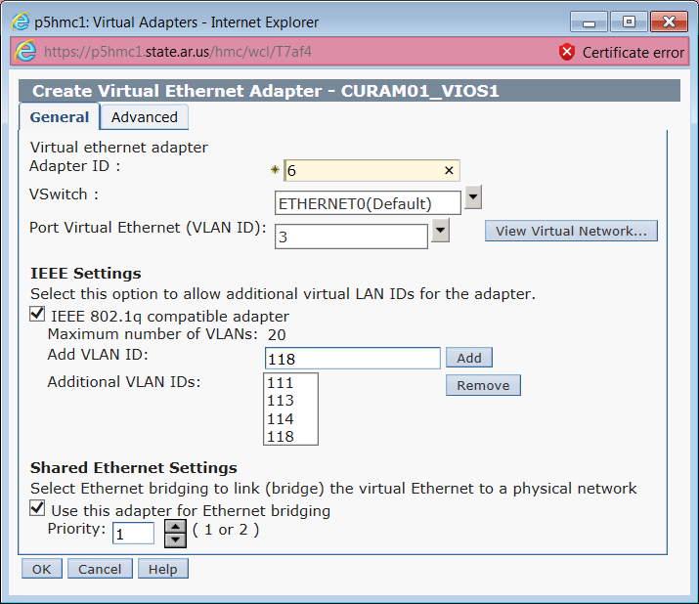
Screen after hitting “ok” on the DLPAR screen showing it’s in the config.
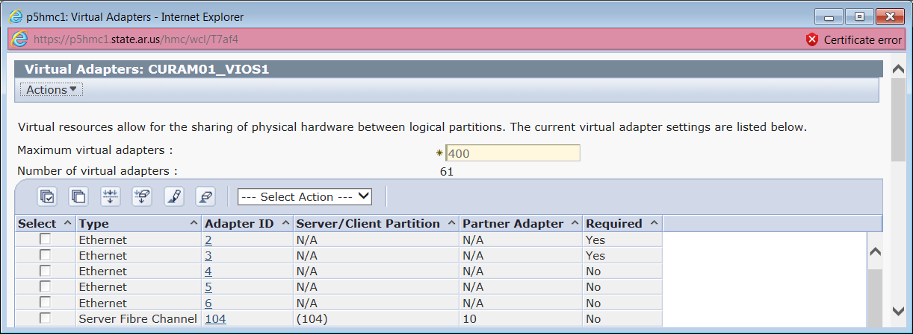

After hitting “ok” on the previous screen.
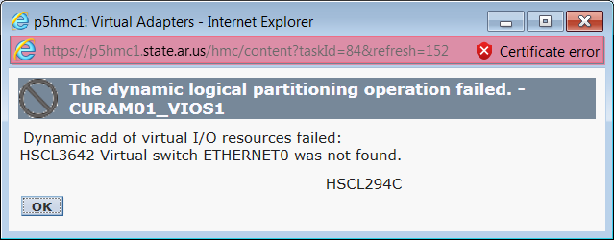
This is the list of VSwitches defined for thise managed system. Neither of these is listed in the VSwitch dropdown on the first screen.
